To: Vinny Saccenti

Re: Vulnerable WebApp

From: Team3

On our WebAPI we discovered that there was a vulnerability in node.js that allowed for remote code execution (RCE). This was because of the “@eval” flag in php. We replaced node with apache2 because the website is static and does not need node, which is more vulnerable. We also noticed a php webshell in the html directory, to rectify this we disabled execution permissions on the file. Below is a screenshot of the node.js and our team disabling execution permissions in the php webshell.

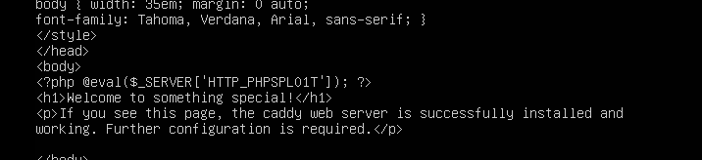

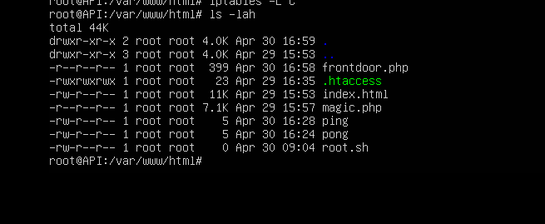

Best,

Team3